AUDITIONS August 21 3-6pm August 22 7-9:30pm For ages 17 and older - Prepare 16 bars of Music Girls and Guys auditioning for Cagelles be prepared to dance. Bring your heels!
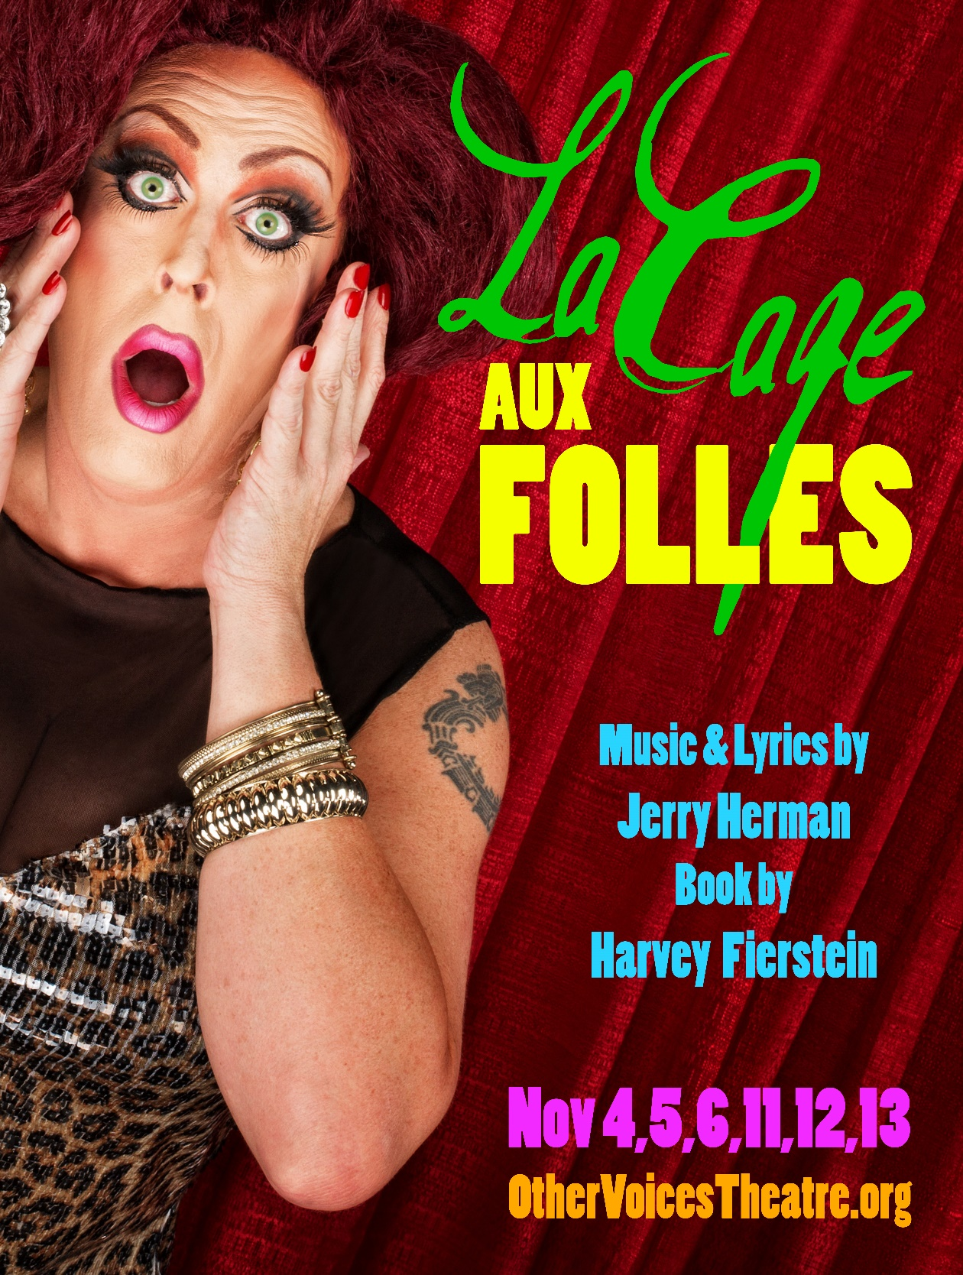
Other Voices Theatre at The Performing Arts Factory OtherVoicesTheatre.org 244 S. Jefferson St Frederick, MD 21701 301-662-3722

